**HCI Assignment 2**

Original Layout:

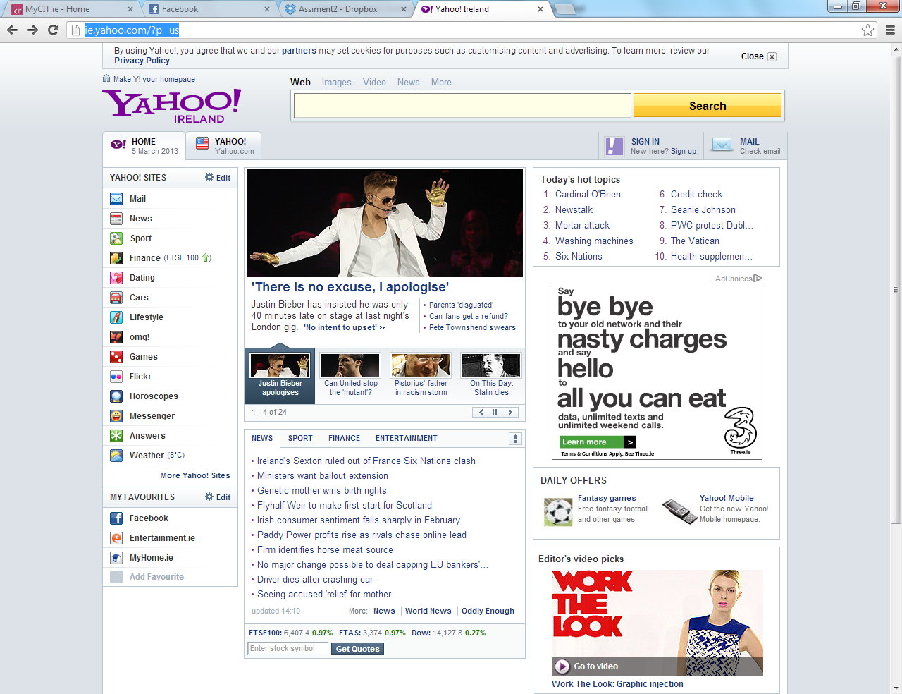

Prototype Redesign:

Image1

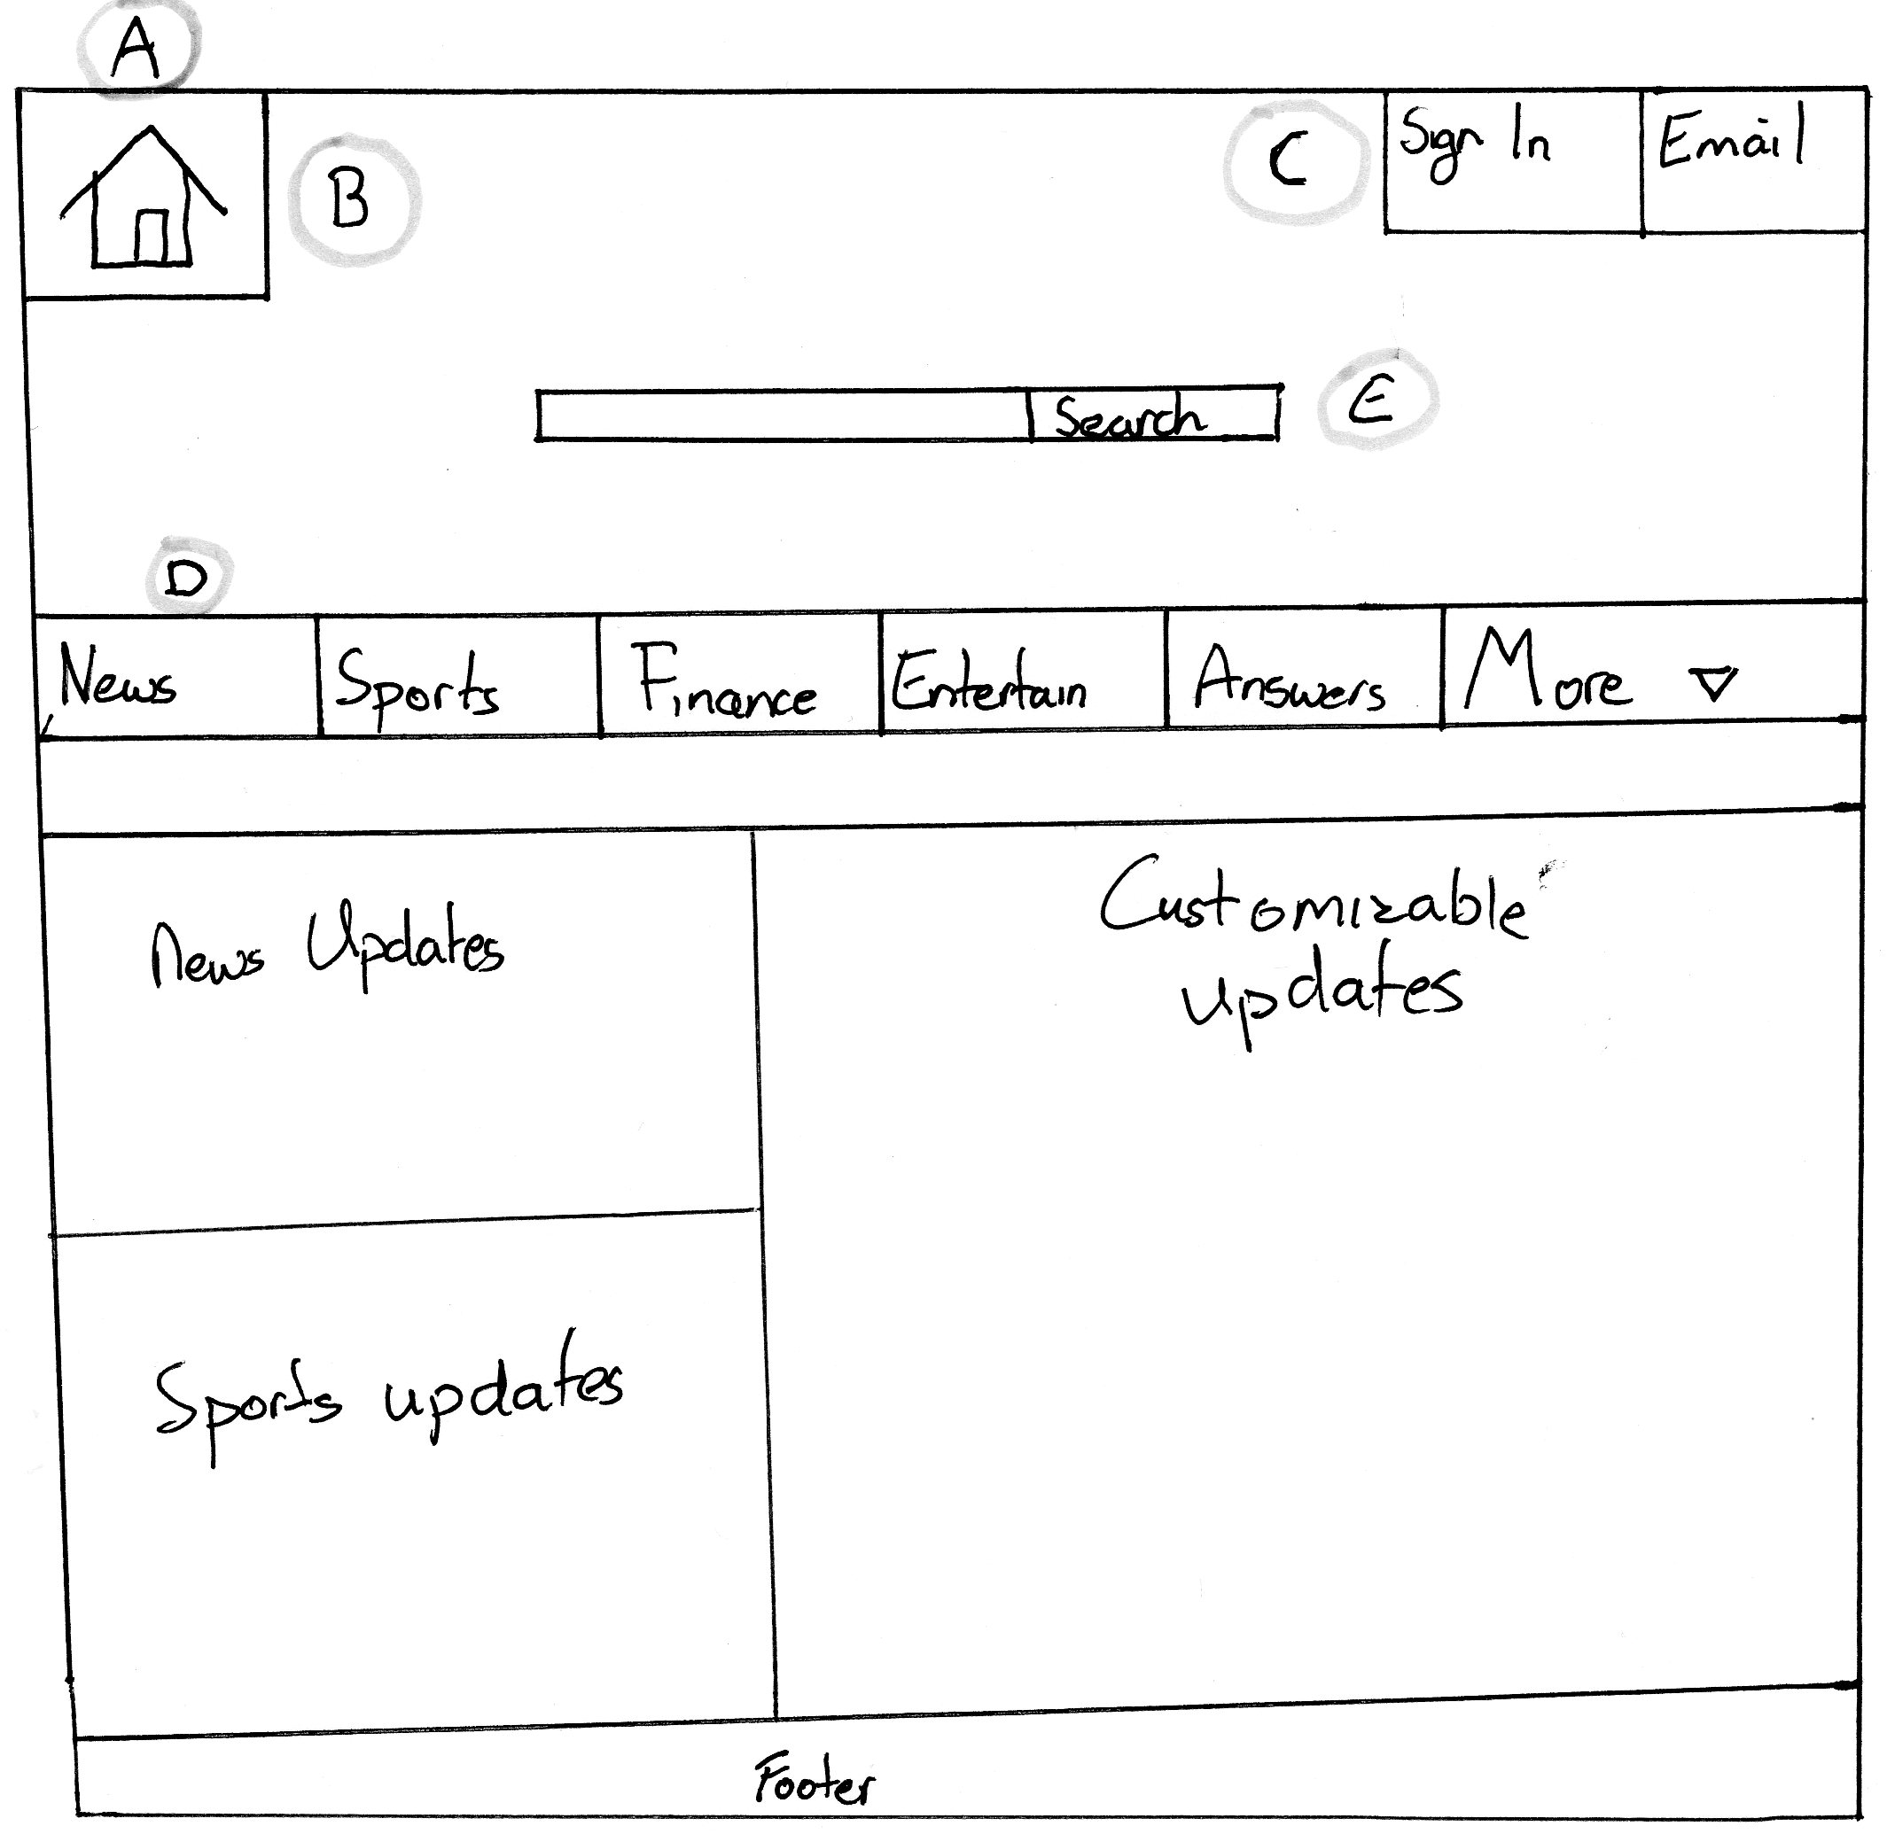

Image2

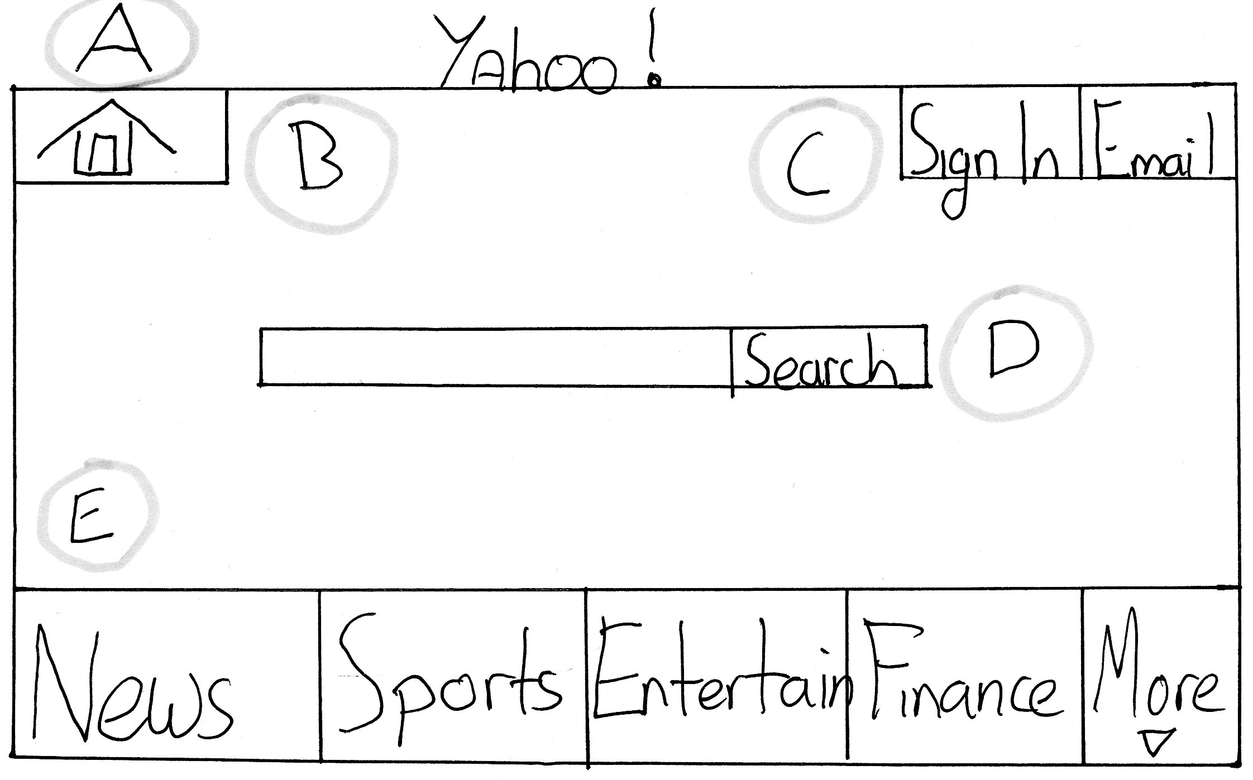

**Overview:**

My redesign was mainly focused on the navigation of the site because in its original design, Yahoo! did not have a good navigation system. The main problems I have addressed are as follows

* The home icon
* The position of the Home link on all pages
* The position of the Sign In link on all pages
* More focus on the search bar
* Easier navigation around the sites pages using a navigation bar with all the links

I think my redesign would improve the site greatly as there would not be so much confusion in navigating around the site anymore as things would stay in their position throughout the website and keep the same icons for their links. Also as you can see from Image 1 I have redesigned how their headlines are laid out. In my opinion their original layout was very cluttered and was not very clear in what they were showing. In my design you have two main update feeds which are News and sports as they would be the most used on the site. Then I have designed a customizable feed where you can choose what updates appear according to your preference. So as you can see my redesign keeps the original focus for the site but improves on a few small things that can be quite annoying.

**Problems**

**A:**

As you can see from my image 2 I have redesigned the home icon to make it more noticeable and obvious. From the original design you can see the home link is very hard to find and understand what it is. In my design I decided to go with a more traditional icon for my link. I chose a house because in my opinion if it’s not broken don’t fix it and I think the house works perfectly at suggesting that it is a home link and everyone can understand it.

**B:**

In the original design of Yahoo! the home icon changed position and also changed its icon frequently changed as you navigated through the pages of the site. In my design I have put the link in the top left corner where it will stay no matter what page you are on. This will make it easier for the user to navigate home no matter what page they are currently on as moving the link around too much can cause a lot of confusion.

**C:**

Another problem that occurred on the original design was the sign in link would move position as you navigated around the site which will cause major confusion for the user. In my design I put the link in the top right corner where it will stay throughout the website as this will make it easier for users to sign in no matter what page they are on. Also when you sign in the sign in link will be replaced with your user name and a drop down menu that will allow you to sign out.

**D:**

In the original design I felt the search bar was hidden away and I know Yahoo! wasn’t designed as a search engine but I still felt like it could be drawing more attention to its search bar. In my design I did not make the whole web page about the search bar but I did draw a lot more attention to it as I feel it is a really good feature for the web site and should be focused on a lot more by Yahoo! I have placed its more centred to the screen and at the top where it is one of the first things the user sees.

**E:**

With the links in my design I decided to go with a newer approach of using a navigation bar with a drop down menu with more links in it. I felt this was more modern as a lot less cluttered then Yahoo!’s original design. Putting it here on all pages also means you can navigate to all of Yahoo!’s pages no matter where you are in the site which makes the site very efficient.

**Conclusion**

In my opinion my prototype design fixed a lot of small but annoying issues within Yahoo! such as the overall layout of the website. My design fixed a lot of clutter that was unnecessary for Yahoo!. Also I fixed a lot of navigation issues that would cause confusion amongst users. Though the changes I made to the site weren’t all that important they fixed a lot of issues that Yahoo! seems to have overlooked in their design which would result in loss of customer satisfaction with their website.